# Arrays

Arrays allow a **single variable** to hold **multiple values**.

## Syntax

** **const cannot be reassigned**.

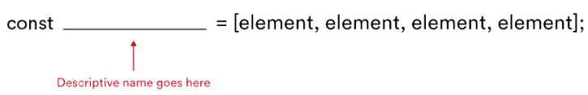

const beverages = ["coffee", "tea", "hot chocolate", "milk"];

const leapYears = [2016, 2020, 2024, 2028];

Arrays can also contain **different** datatypes(arrays are seldom used like this though);

const stuff = ["red", 42, "gorilla", false];

Arrays allow us to:

* Reorder elements.
* Identify the value of one element in a list by specifying its position.
* Go through a list item by item and manipulate each element.

## Indexes

In an array, each element has an index, which tells us their order in the array. The first element has an index of [0], the second element has an index of [1], and so on.

## Replacing an element in an array

Just write an assignment operator as below:

const characters = ['Darth Vader', **'Princess Leia'**, 'Han Solo', 'Luke Skywalker'];

characters[1] = 'Yoda';

//=> const characters = ['Darth Vader', **‘Yoda’**, 'Han Solo', 'Luke Skywalker'];

## The Length Property

.length tells us how many elements are present in the array

['John', 'Paul', 'Mary'].length;

// => 3

const favoriteAthletes = ['Michael Jordan', 'Serena Williams', 'Babe Ruth', 'Muhammad Ali', 'Stephen Curry'];

favoriteAthletes[favoriteAthletes.length - 1];

// => 'Stephen Curry'.

favoriteAthletes[favoriteAthletes.length - 2];

// => 'Muhammad Ali'.

## Push and Pop

const ghosts = ['blinky', 'inky', 'pinky'];

ghosts.push('clyde');

ghosts;

// => ['blinky', 'inky', 'pinky', 'clyde']

ghosts.pop();

ghosts;

// => ['blinky', 'inky', 'pinky']